LAB EXPERIMENT RECORD

SET 11 — Product Category Analysis

Department | AIDS
Course Code / Course Name | DSA0602 / Data Handling and Visualization
Experiment | Data Visualization using R
Name | GOPIKHA S
Register Number | 1924260143
Date | 6 October 2026
Day | Tuesday

Aim

To analyze product category sales data using R by creating a funnel chart, sales data table, interactive R Shiny dashboard, and pie chart for effective visualization and comparison of sales across different product categories.

Dataset

Product Category Sales Dataset

Category | Sales (in $)
Electronics | 50000
Clothing | 35000
Appliances | 40000

Program 1 — Funnel Chart for Sales

Aim

To create a funnel-style chart showing the sales values of each product category.

R Code

# Product Category Sales Data
category <- c("Electronics", "Clothing", "Appliances") sales <- c(50000, 35000, 40000)
sales_data <- data.frame( Category = category, Sales = sales
)
# Sort sales in descending order
sales_data <- sales_data[order(-sales_data$Sales), ] # Create funnel-style chart
barplot( sales_data$Sales,
names.arg = sales_data$Category,
main = "Product Category Sales Funnel", xlab = "Product Category",
ylab = "Sales ($)",
col = c("skyblue", "orange", "lightgreen"), ylim = c(0, 60000)
)

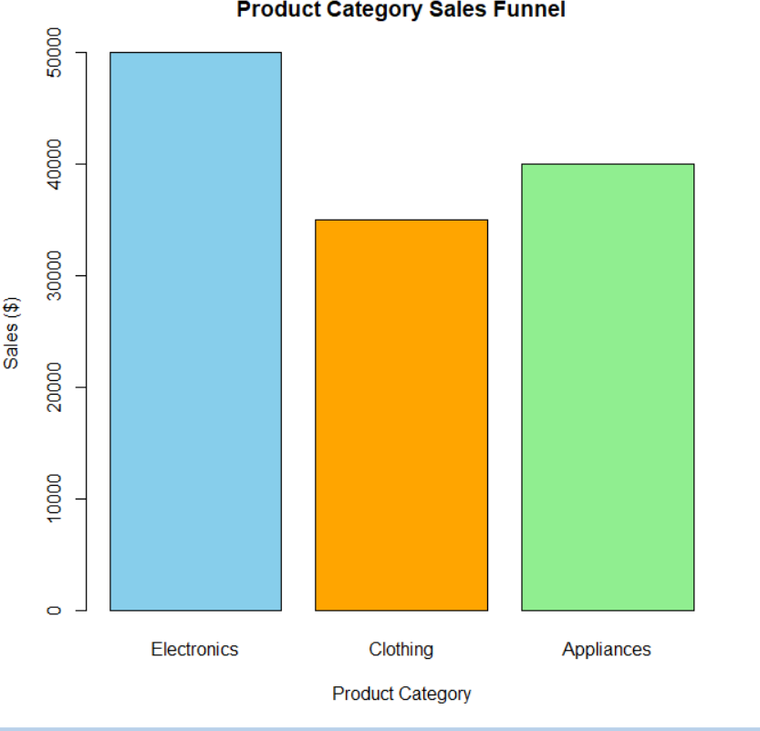

Observation

The chart displays the sales values of Electronics, Appliances, and Clothing. Electronics has the highest sales, followed by Appliances and Clothing.

Program 2 — Sales Data Table

Aim

To create and display a table containing product category and sales information.

R Code

# Product Category Sales Data
category <- c("Electronics", "Clothing", "Appliances") sales <- c(50000, 35000, 40000)
sales_data <- data.frame( Category = category, Sales = sales
)
# Display sales table sales_data
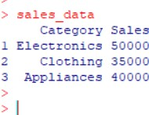

Observation

The table displays the sales information for all three product categories. Electronics has sales of
$50,000, Clothing has $35,000, and Appliances has $40,000.

Program 3 — R Shiny Interactive Dashboard

Aim

To develop an interactive dashboard combining a pie chart, funnel chart, and sales table using R Shiny.

R Code

# Install packages if required # install.packages("shiny") library(shiny)
# Dataset
sales_data <- data.frame(
Category = c("Electronics", "Clothing", "Appliances"), Sales = c(50000, 35000, 40000)
)
# UI
ui <- fluidPage(
titlePanel("Product Category Analysis Dashboard"), tabsetPanel(
tabPanel( "Pie Chart",
plotOutput("pieChart")
),
tabPanel( "Funnel Chart",
plotOutput("funnelChart")
),
tabPanel( "Sales Table",
tableOutput("salesTable")

)

)
)

# Server
server <- function(input, output) { # Pie Chart
output$pieChart <- renderPlot({

pie(
sales_data$Sales,
labels = sales_data$Category,
main = "Sales Distribution by Product Category"
)

})

# Funnel Chart
output$funnelChart <- renderPlot({

sorted_data <- sales_data[ order(-sales_data$Sales),
]

barplot( sorted_data$Sales,
names.arg = sorted_data$Category,
main = "Product Category Sales Funnel", xlab = "Product Category",
ylab = "Sales ($)",

col = c( "skyblue", "orange", "lightgreen"
),
ylim = c(0, 60000)
)

})

# Sales Table
output$salesTable <- renderTable({ sales_data
})

}

# Run Shiny Application shinyApp(
ui = ui,
server = server
)

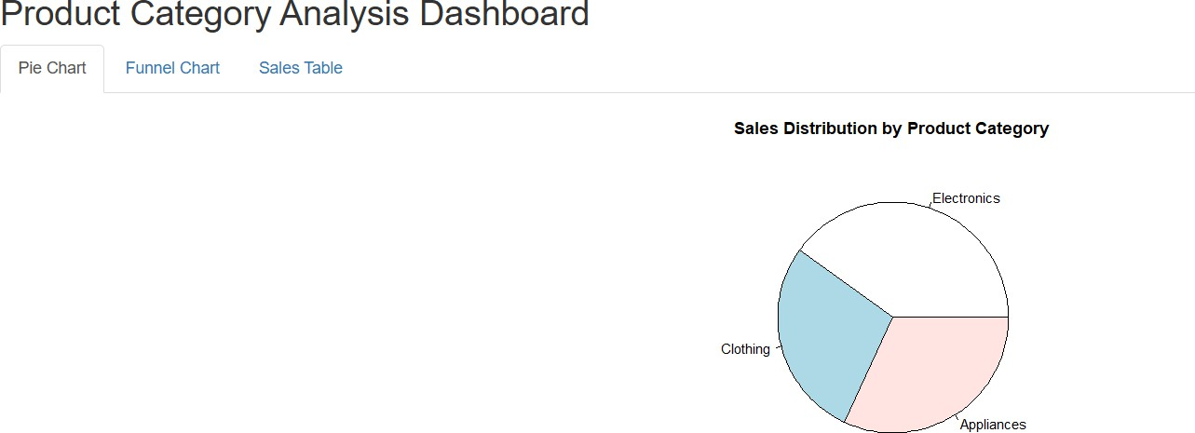
Observation

The R Shiny dashboard provides an interactive interface containing the pie chart, funnel chart, and sales data table. The dashboard allows the user to view the product category sales information in different visual formats.

Program 4 — Pie Chart for Sales Distribution

Aim

To create a pie chart representing the sales distribution among different product categories.

R Code

# Product Category Sales Data

category <- c( "Electronics", "Clothing", "Appliances"
)

sales <- c( 50000,
35000,
40000
)

# Create pie chart pie(
sales,
labels = category,
main = "Sales Distribution by Product Category"
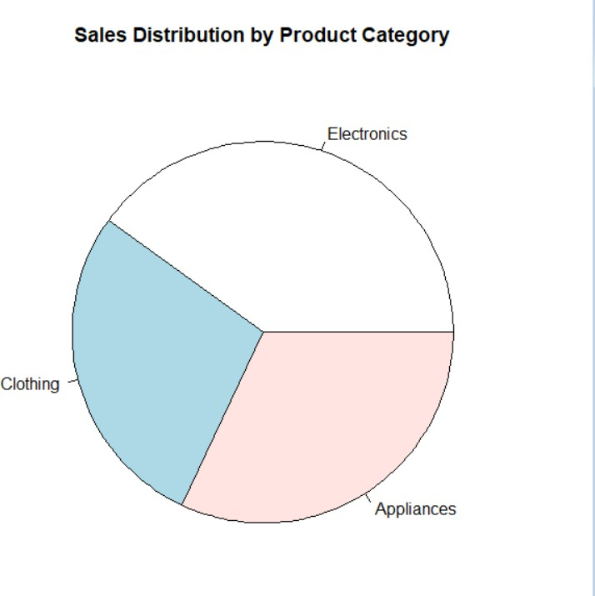
)

Observation

The pie chart represents the proportion of total sales contributed by each product category. Electronics contributes the largest share, followed by Appliances and Clothing.

Overall Procedure

  - Create the product category sales dataset in R.
  - Store the category names and corresponding sales values.
  - Create a funnel-style chart using the sales values.
  - Display the product category data using a table.
  - Develop an interactive dashboard using R Shiny.
  - Include the pie chart, funnel chart, and sales table in the dashboard.
  - Create a separate pie chart to visualize sales distribution.
  - Compare the sales values of the different product categories.

Result

The product category sales data was successfully analyzed and visualized using R. The funnel chart, sales table, R Shiny dashboard, and pie chart clearly represent the sales performance of Electronics, Clothing, and Appliances.
The analysis shows that Electronics has the highest sales ($50,000), followed by Appliances ($40,000) and Clothing ($35,000).

Key R Functions Used

Function | Purpose
data.frame() | Creates the sales dataset
c() | Creates vectors
barplot() | Creates the funnel-style bar chart
pie() | Creates the pie chart
order() | Sorts sales values
library(shiny) | Loads the Shiny package
fluidPage() | Creates the Shiny UI
tabsetPanel() | Creates dashboard tabs
plotOutput() | Displays plots in Shiny
renderPlot() | Generates plots dynamically
renderTable() | Displays the data table
tableOutput() | Displays a table in Shiny
shinyApp() | Runs the Shiny application

